Sam Houston State University
College of Science & Engineering Technology
Computer Science - Software Engineering
Final Project
Classifying Satellite Images of Land Use with an MLP and a CNN
COSC 4050 01 Independent Study
Fall 2026
Instructor: Dr. Haodi Jiang
Mustafa Cil
Student ID 001060860
29 October 2026

Dataset and algorithms
My project is a classification task. The input is a small satellite image and the output is one of ten land use classes, for example Forest, Highway, River or Residential.
Dataset. I use EuroSAT, RGB version (Helber et al., 2018), downloaded from Zenodo. Every image is 64 by 64 pixels with three colour channels. I split every class 80% for training and 20% for testing, and I keep a random tenth of the training part for validation. My program prints the sizes: 19440 training, 2160 validation and 5400 test images.
Algorithms. I compare two neural networks, an MLP and a CNN. My data are images, and neural networks are the usual choice for image classification. I picked these two because they differ in one clear way. The MLP is the simplest neural network and it treats the image as a plain list of numbers. The CNN is the standard network for images and it uses the fact that neighbouring pixels belong together. So the comparison shows how much it helps when a model knows the structure of an image. I train both with Adam (learning rate 0.001), batches of 64 and cross entropy loss.
- MLP (multilayer perceptron): An MLP is the basic neural network. It has layers of neurons, and every neuron is connected to every input of the layer before it. Each neuron multiplies its inputs by weights, adds them up and passes the result through an activation function (ReLU), and training changes the weights step by step so that the right class gets the highest score. To use it on an image, I first flatten the image into one list of 12288 numbers. My MLP has one hidden layer of 256 neurons and an output layer with one score per class. It has 3148554 parameters and I train it for 20 epochs.
- CNN (convolutional neural network): A CNN is a neural network made for images. Instead of connecting every neuron to every pixel, it slides small filters over the image, and each filter gives a high value where it finds its pattern, for example an edge or a colour change. Pooling layers then make the image smaller so the next filters see bigger areas, and at the end a normal dense layer turns the found patterns into one score per class. My CNN has three blocks of 3 by 3 filters and max pooling, then a dense layer of 64 neurons. It has 319178 parameters and I train it for 10 epochs.
The parameters are the weights of the model. I do not set them, the training learns them. What I choose are the sizes of the layers, and the number of parameters follows from them. I did not search for the best sizes. I took common sizes that train in a few minutes on a laptop CPU, 256 neurons for the MLP and 32, 64 and 64 filters for the CNN. The MLP even has about ten times more parameters, so if the CNN wins, it is not because it is bigger.
One CNN epoch takes much longer than one MLP epoch on my laptop, so I stop the CNN at 10 epochs. The MLP is fast but learns slowly, so it gets 20.

How to run it
I use Python with PyTorch, scikit-learn, numpy and matplotlib. Inside the project folder I make a virtual environment, install the libraries from requirements.txt, download the images and run the two scripts:
python3 -m venv .venv
source .venv/bin/activate
pip install -r requirements.txt
sh data/get_data.sh
python code/mlp.py
python code/cnn.py
The scripts save their figures in outputs/. After training, each script saves its model in models/, and the next run loads it instead of training again. The trained models are already in the project folder, so to train again I delete models/mlp.pt and models/cnn.pt.
dataset.py reads the images and makes the split. common.py has the training loop and the prediction function. The other scripts import both.
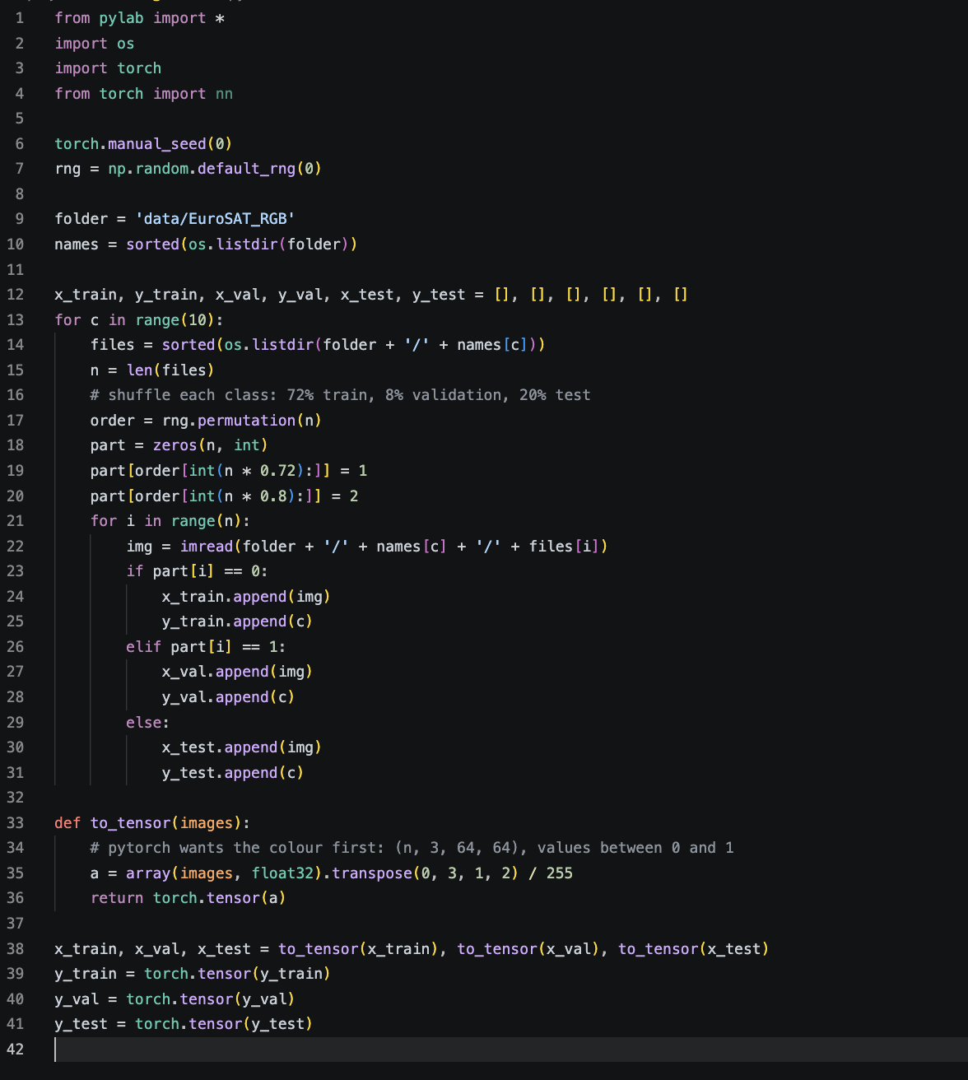
Figure 1. dataset.py reads the images and splits every class into training, validation and test.
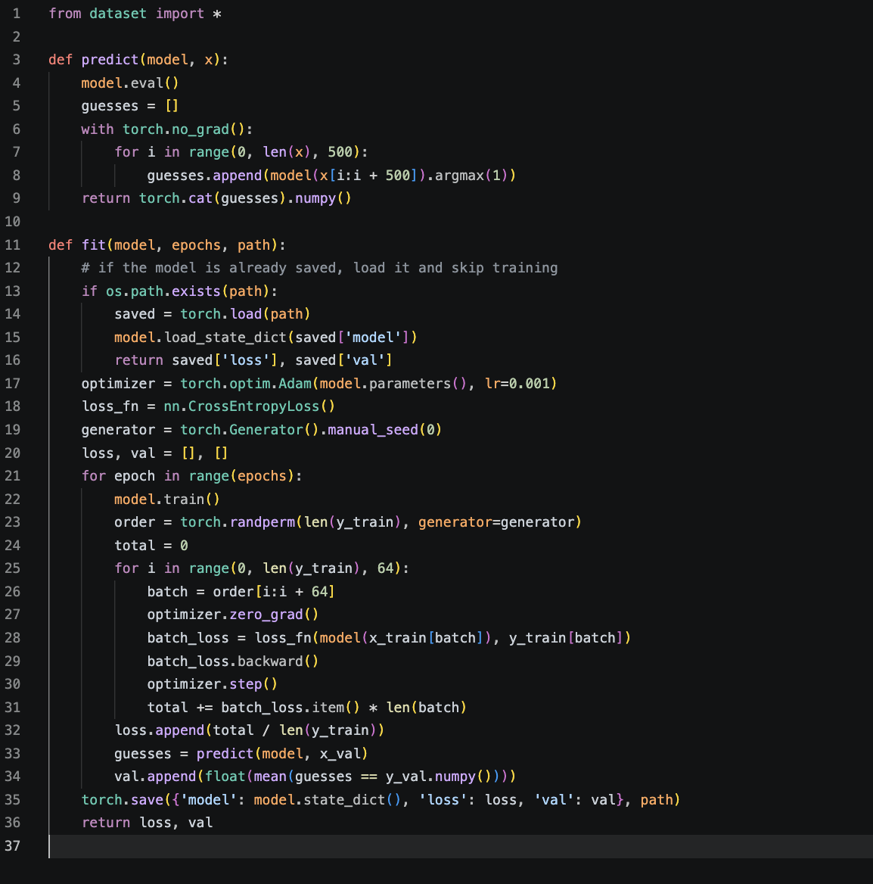
Figure 2. common.py trains a model, or loads it if it was saved before.
mlp.py and cnn.py build and train the models. They print the loss and the validation accuracy after every epoch. At the end they test the model and print the classification report of scikit-learn: precision, recall and F1 for every class, the accuracy, and the macro average over the ten classes. They also draw the confusion matrix.
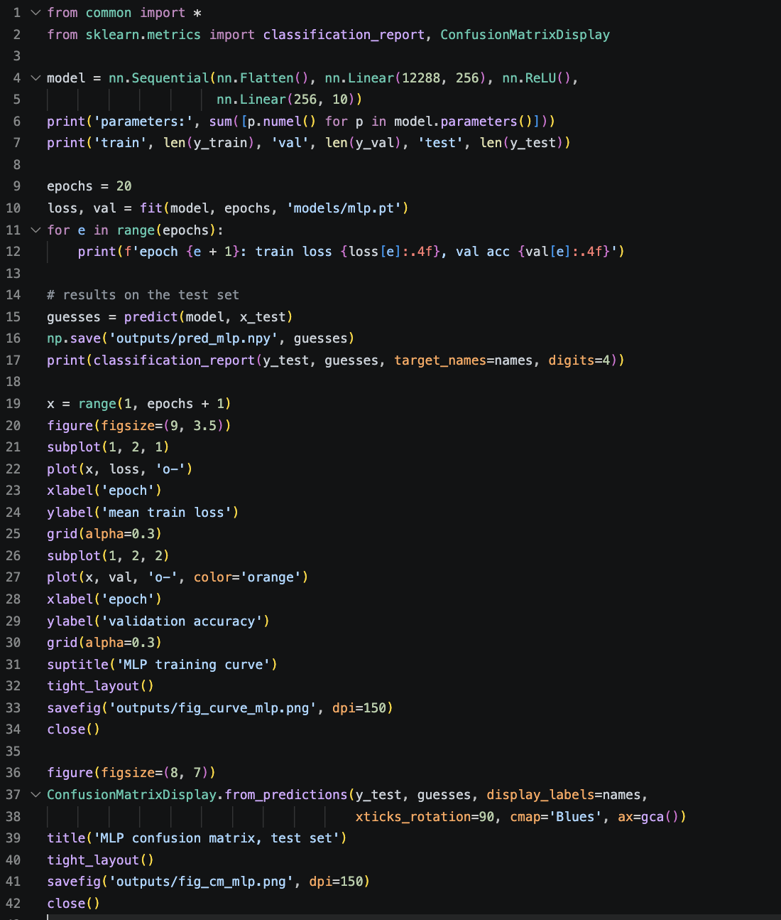
Figure 3. My code for the MLP.
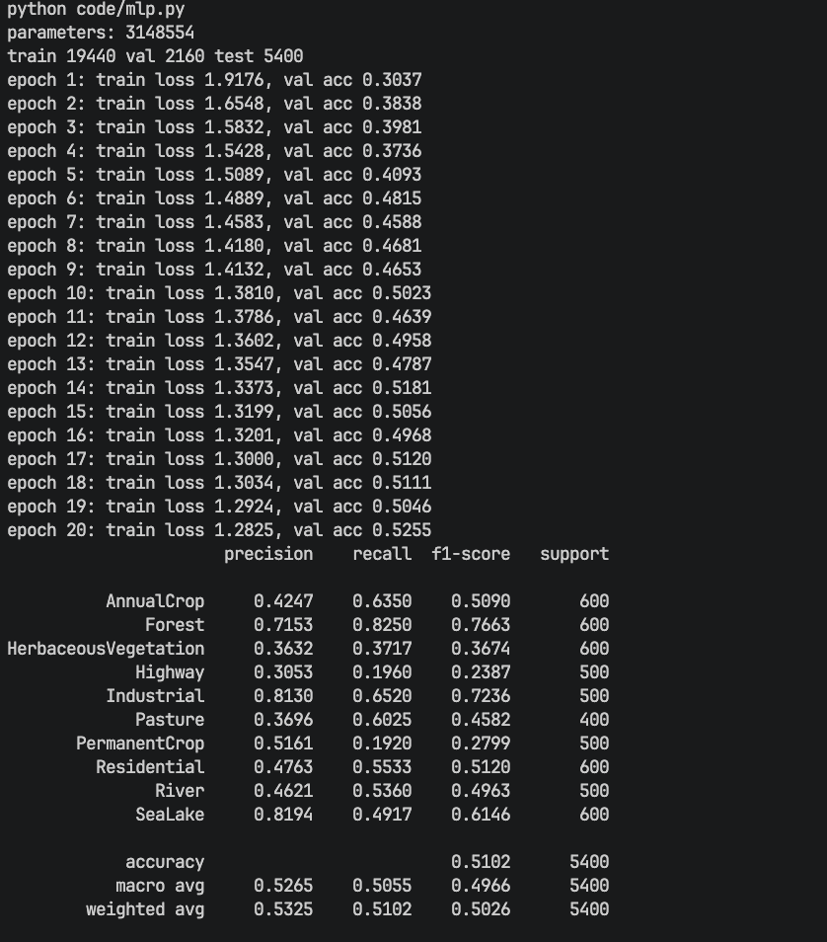
Figure 4. The output of mlp.py.
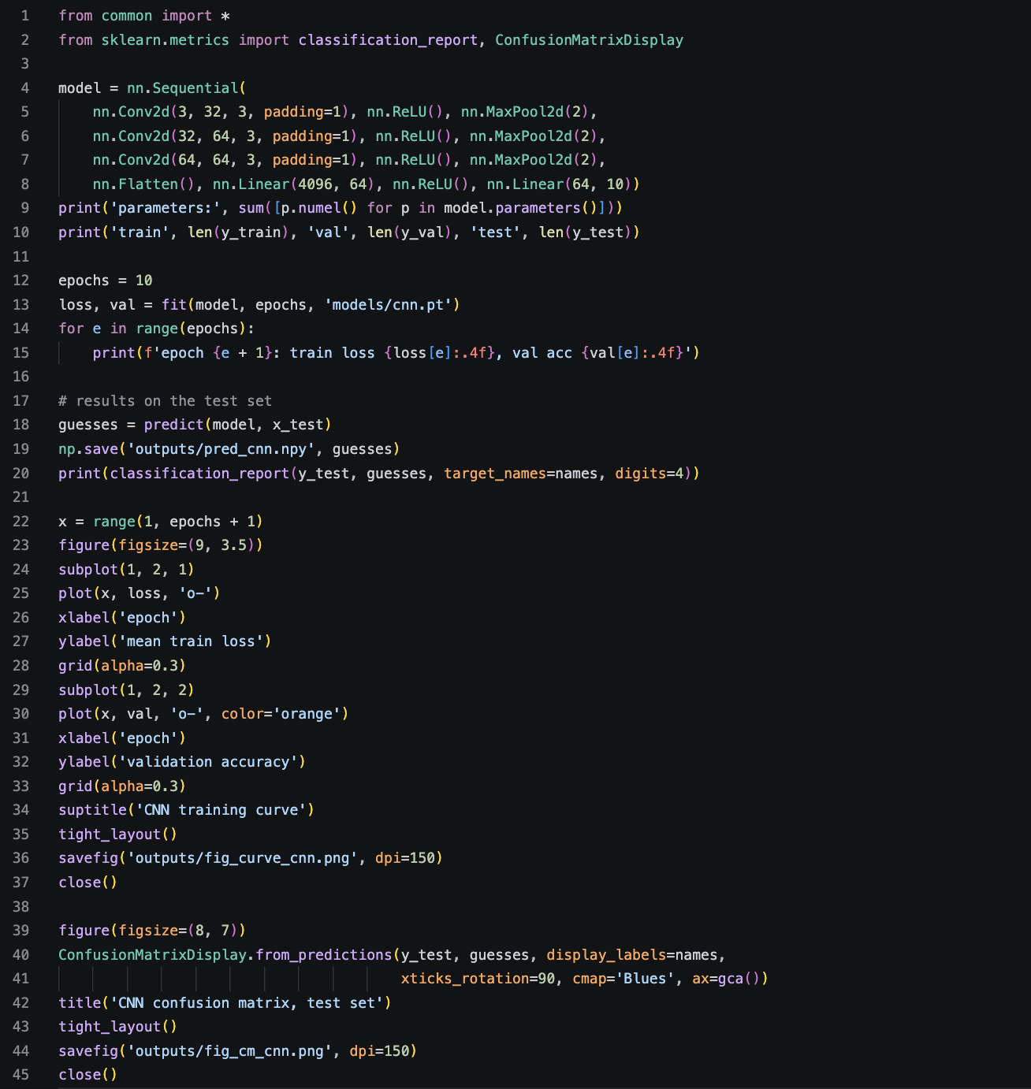
Figure 5. My code for the CNN.
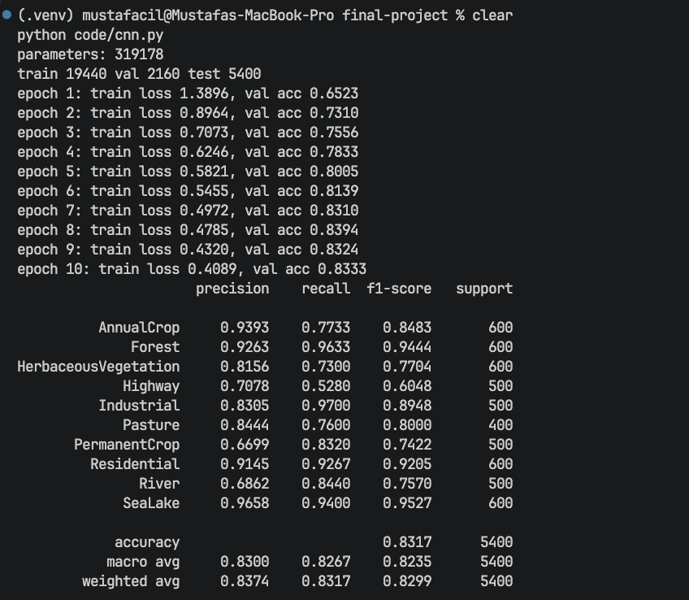
Figure 6. The output of cnn.py.
I also made a small web page to try the models. From the project folder I start it with sh demo/start.sh. The first time, it also installs the libraries, downloads the images and trains the models if they are missing. On the page I can pick a test image or upload my own, and both models show their probability for every class.
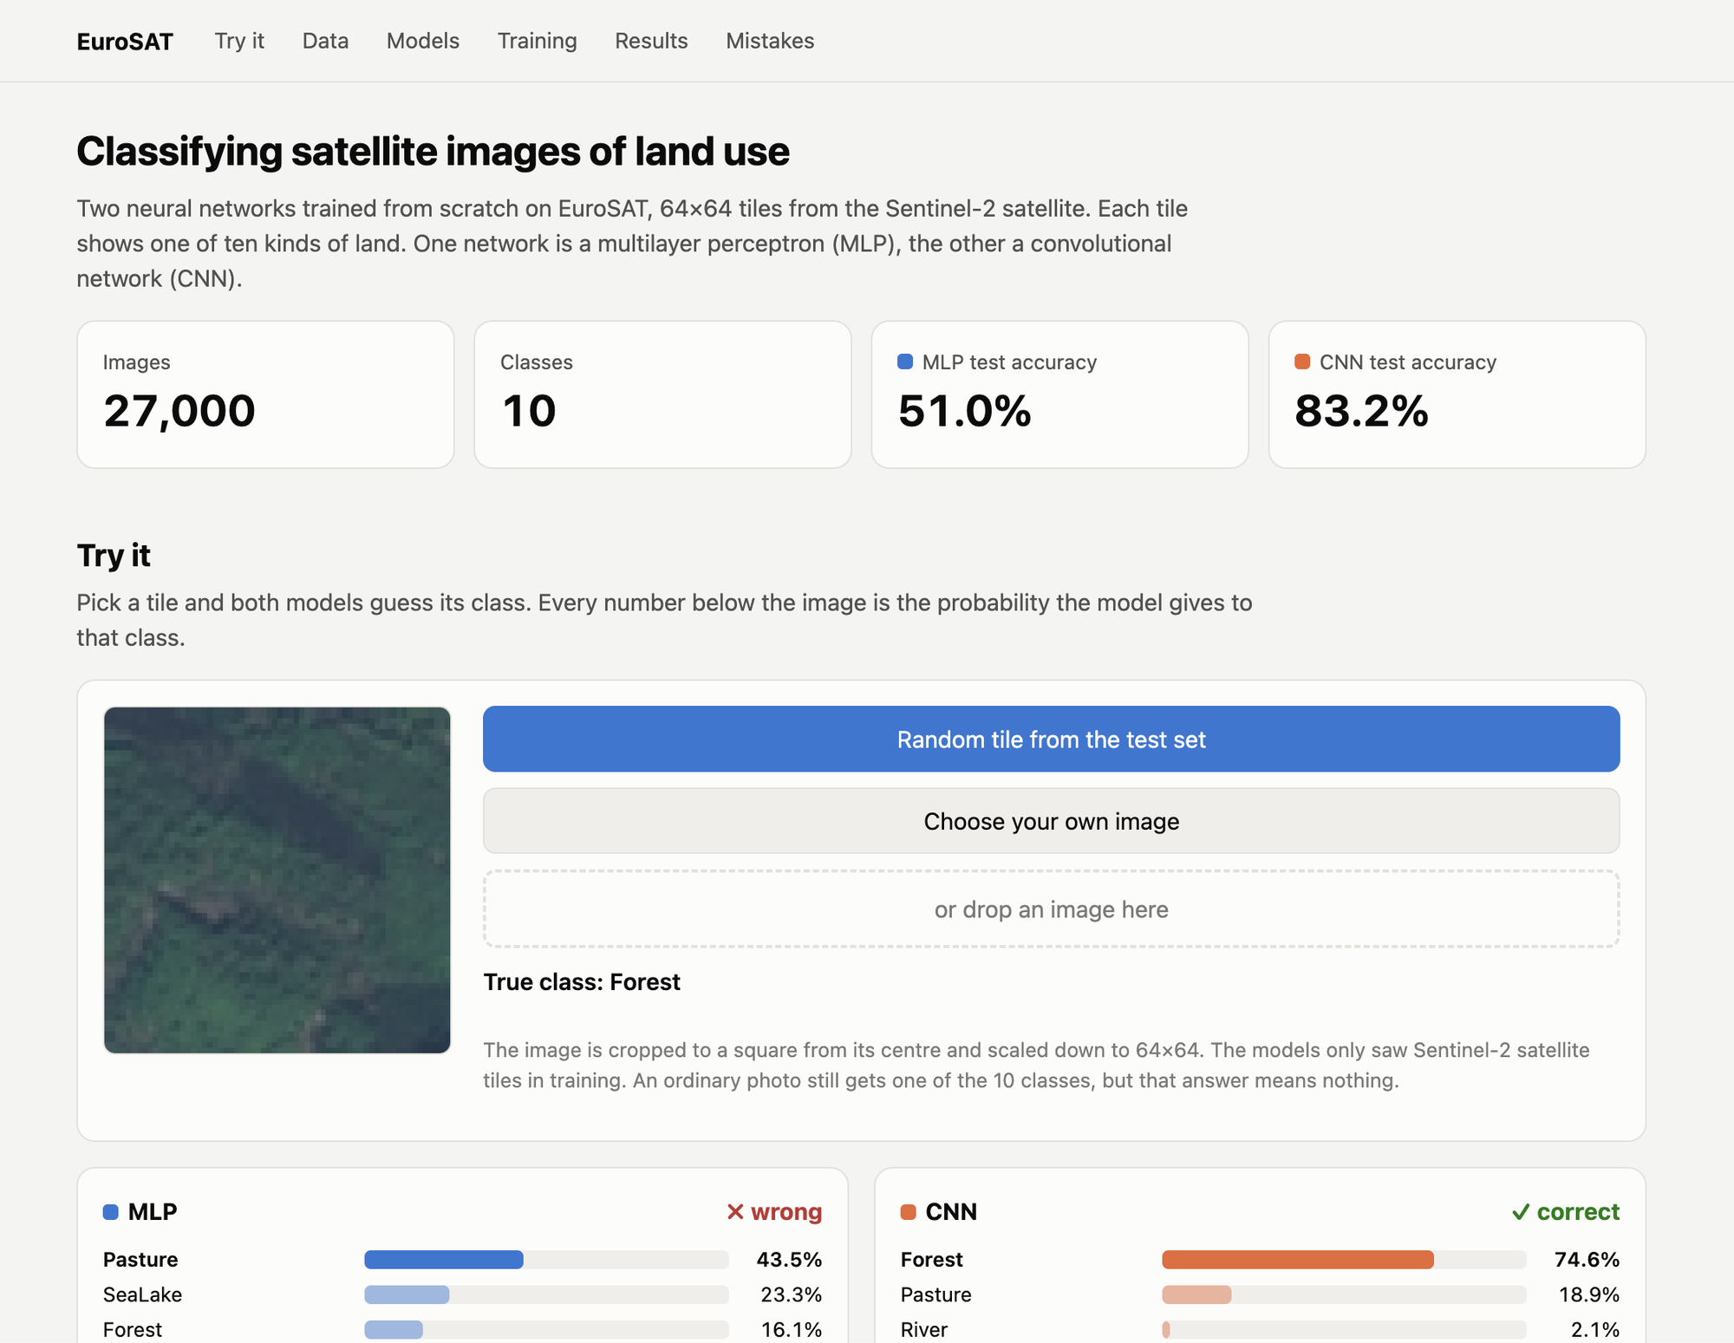
Figure 7. The web demo with a Forest test image. The CNN is right, the MLP says Pasture.

Comparison
These are the results on the 5400 test images, taken from the accuracy and macro average lines of the two classification reports:
Model | Accuracy | Precision | Recall | F1 | Parameters
MLP | 0.5102 | 0.5265 | 0.5055 | 0.4966 | 3148554
CNN | 0.8317 | 0.8300 | 0.8267 | 0.8235 | 319178
The CNN is better in every metric, with about ten times fewer parameters. This is what each metric means and what the two models get:
- Accuracy is the share of all test images that the model gets right. The MLP gets 0.5102, so about every second image is wrong. The CNN gets 0.8317, so it is right for about five images out of six.
- Precision looks at one class at a time: when the model says “Forest”, how often is it really Forest? The macro average over the ten classes is 0.5265 for the MLP and 0.8300 for the CNN. So when the MLP gives a label, it is right only about half of the time.
- Recall also looks at one class: of all the real Forest images, how many does the model find? The MLP gets 0.5055 and the CNN 0.8267. The MLP misses some classes almost completely: its recall is only 0.1920 for PermanentCrop and 0.1960 for Highway.
- F1 combines precision and recall into one number. It is only high when both are high, so a model cannot get a good F1 by being good at just one of them. The MLP gets 0.4966 and the CNN 0.8235.
For the CNN all four numbers are close to each other, around 0.83. This means it is good in a balanced way: it finds most images of a class, and its labels are mostly correct. The MLP is low in all four. One class shows the difference between precision and recall well. For SeaLake the MLP has a precision of 0.8194 but a recall of only 0.4917. When it says SeaLake it is usually right, but it misses half of the lakes, many of them because it calls them Pasture.
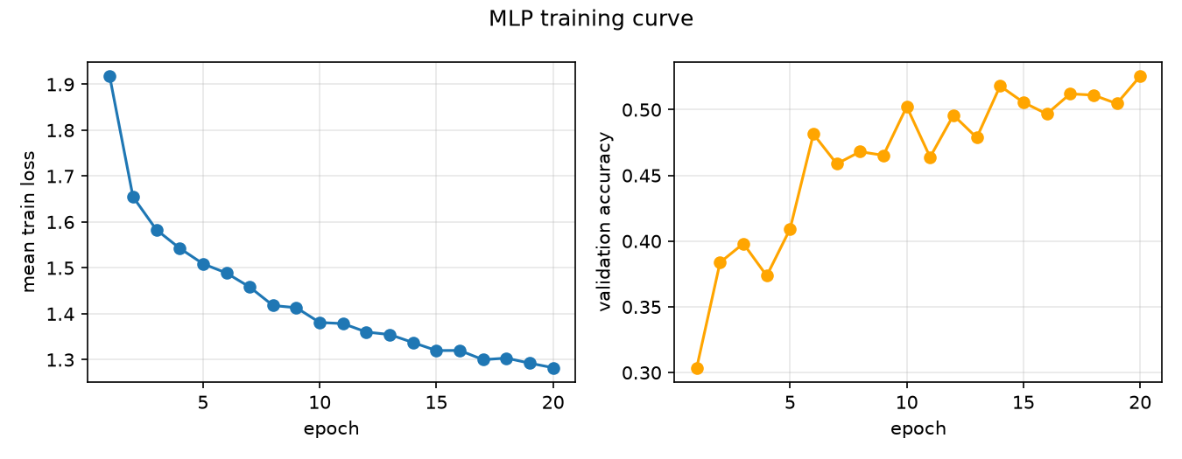
Figure 8. Training curve of the MLP. The validation accuracy goes up from 0.3037 to 0.5255, but not smoothly.
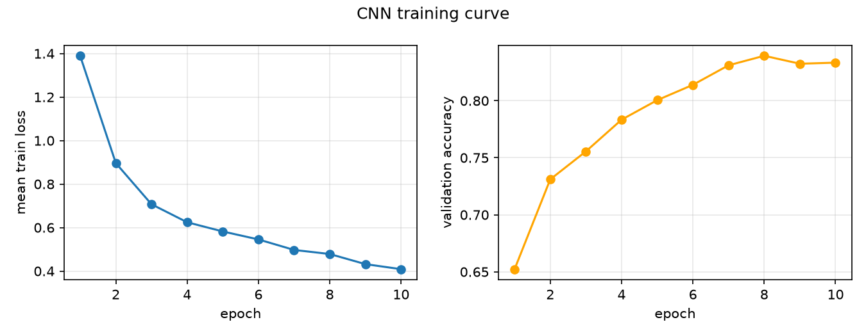
Figure 9. Training curve of the CNN. The validation accuracy starts at 0.6523 and does not go up after epoch 8.
After one epoch the CNN is already better than the MLP after 20 epochs. The CNN reaches its best validation accuracy, 0.8394, at epoch 8, and it does not go up in the last two epochs. The MLP is still slowly going up at epoch 20.
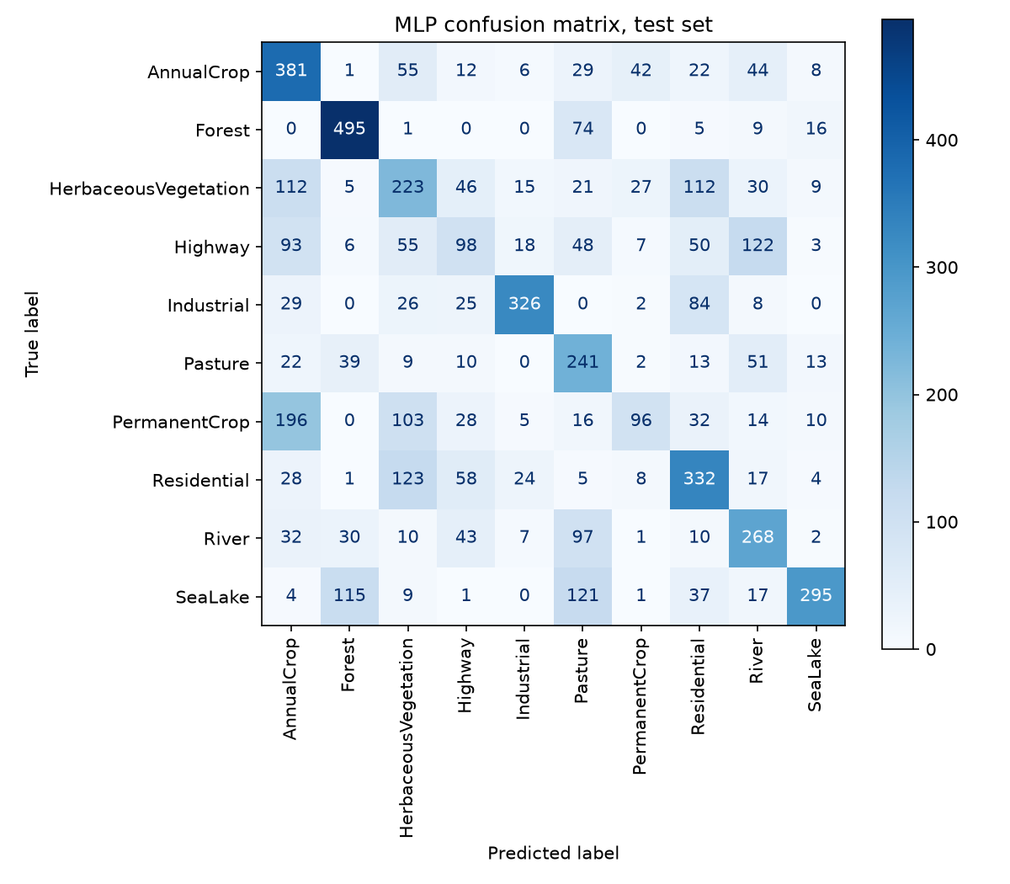
Figure 10. Confusion matrix of the MLP on the test set. Rows are the true class, columns the guess.
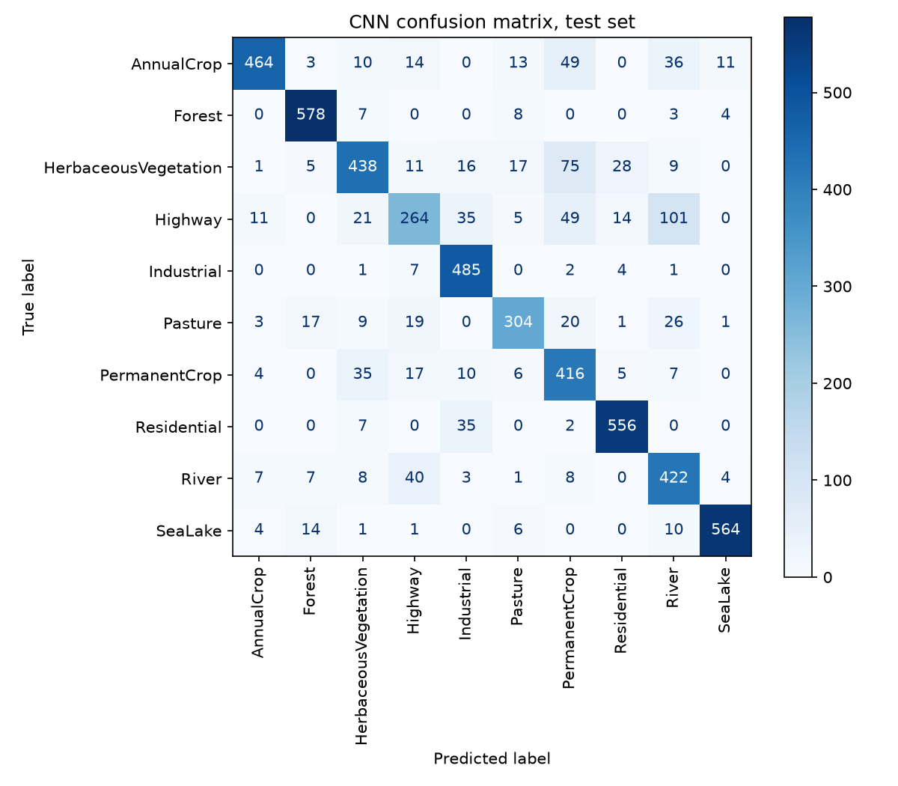
Figure 11. Confusion matrix of the CNN on the test set.
The MLP makes mistakes in almost every class. In Figure 10 its four biggest mistakes are PermanentCrop taken as AnnualCrop (196), Residential taken as HerbaceousVegetation (123), Highway taken as River (122) and SeaLake taken as Pasture (121). Many of these pairs have similar colours, so I think colour is a big part of how the MLP decides. The biggest mistake of the CNN in Figure 11 is Highway taken as River (101). Highway is also its weakest class, with a recall of 0.5280. At this resolution a road and a river are both a thin line through green land, so this mistake makes sense.

Why the CNN is better
The two models see the same images and train in the same way, so the gap comes from how they are built. I see three reasons.
The MLP loses the shape of the image. Its first step is Flatten. It turns the 64 by 64 by 3 image into a list of 12288 numbers. After that, two pixels that are next to each other are just two numbers in a list, the same as two pixels from opposite corners. But a field, a road or a group of roofs is a pattern of neighbouring pixels, so the MLP has to find these patterns without knowing which pixels are neighbours.
The CNN looks at small areas and shares its filters. A 3 by 3 filter looks at one pixel and its eight neighbours, and the same filter slides over the whole image. So the CNN learns a pattern like an edge once and can find it anywhere in the image. This is called weight sharing. In the MLP every neuron has its own weight for every pixel, so the same pattern in a different place is a new thing it has to learn again. This is also why the MLP has 3148554 parameters and the CNN only 319178. Almost all weights of the MLP are in its first layer.
The CNN builds bigger patterns step by step. Max pooling makes the image half as wide and half as high after every block. The first filters find small things like edges and colour changes, the next ones combine them into stripes and corners, and the last ones see a large part of the image.
My results agree with this. With far fewer parameters, the CNN even fits the training images much better: its train loss at the last epoch is 0.4089, the MLP’s is 1.2825. So the MLP is not weak because it memorises the training images (overfitting). It is weak because its structure cannot learn the patterns well, not even on the training data. What it can still use is the colour, and its biggest mistakes are between classes with similar colours (Figure 10).

Conclusion
The CNN is the better model here: 0.8317 test accuracy against 0.5102 for the MLP, with far fewer parameters. The reason is its structure. It looks at neighbouring pixels and reuses the same filters over the whole image, while the MLP loses which pixels are neighbours.
What I learned is that on these images the type of model matters more than the number of parameters. A small CNN beats an MLP that has almost ten times more.

References
Helber, P., Bischke, B., Dengel, A. and Borth, D. (2018). EuroSAT: A Novel Dataset and Deep Learning Benchmark for Land Use and Land Cover Classification (dataset, file EuroSAT_RGB.zip). Zenodo. https://doi.org/10.5281/zenodo.7711810

